Assignment -1

Python Programming

Assignment Date

Student Name Student Roll Number Maximum Marks

19 September 2022

R.V.Akash

310619106007

2 Marks

Question-1:

1. Create registration page in html with username, email and phone number and by using POST method display it in next html page.

Question-2:

1. Develop a flask program which should contain at least 5 packages used from pypi.org

**Note:-** Following application contains (Flask , render_template ,url_for, redirect, request) So both Questions have same Answers

Source Code:

App.py

from flask import Flask, request, render_template, url_for,redirect app = Flask( name )

@app.route('/success/<name>') def success(name):

return 'welcome %s' %name @app.route('/login', methods =['GET', 'POST']) def login():

if request.method=="POST":

first_name = request.form.get("username") email_id = request.form.get("email") phone_num = request.form.get("number")

return "Your name is" +first_name + "Your email is" +email_id + "Your Phone number is"

+phone_num

return redirect(url_for('success',name = first_name))

if name ==' main ': app.run(debug=True)

index.html

<!DOCTYPE html>

<html lang="en">

<head>

<meta charset="UTF-8" />

<meta http-equiv="X-UA-Compatible" content="IE=edge" />

<meta name="viewport" content="width=device-width, initial-scale=1.0" />

<title>Register</title>

<link hre[f="https:](https://cdn.jsdelivr.net/npm/bootstrap%405.2.1/dist/css/bootstrap.min.css)//c[dn.jsdelivr.net/npm/bootstrap@5.2.1/dist/css/bootstrap.min.css](https://cdn.jsdelivr.net/npm/bootstrap%405.2.1/dist/css/bootstrap.min.css)" rel="stylesheet"

integrity="sha384-iYQeCzEYFbKjA/T2uDLTpkwGzCiq6soy8tYaI1GyVh/UjpbCx/TYkiZhlZB6+fzT" crossorigin="anonymous"

**/>**

</head>

<body class="px-4 py-3">

<nav class="navbar navbar-expand-lg navbar-light bg-light">

<a class="navbar-brand" href="#">Flask</a>

<button

class="navbar-toggler" type="button"

data-toggle="collapse"

data-target="#navbarNavAltMarkup" aria-controls="navbarNavAltMarkup" aria-expanded="false"

aria-label="Toggle navigation"

**>**

<span class="navbar-toggler-icon"></span>

</button>

</nav>

<h3>Register</h3>

<form action="http://localhost:5000/login" method="POST">

<div class="form-group">

<label for="exampleInputUserName">UserName</label>

<input type="text"

class="form-control" id="exampleInputUserName" placeholder="UserName" name="username"

**/>**

</div>

<div class="form-group">

<label for="exampleInputEmail1">Email address</label>

<input type="email"

class="form-control" id="exampleInputEmail1" aria-describedby="emailHelp" placeholder="Enter email" name="email"

**/>**

</div>

<div class="form-group">

<label for="exampleInputPassword1">Password</label>

<input type="password" class="form-control"

id="exampleInputPassword1" placeholder="Password" name="password"

**/>**

</div>

<div class="form-group">

<label for="exampleInputPhoneNumber">Phone Number</label>

<input type="number" class="form-control"

id="exampleInputPhoneNumber" placeholder="Phone Number" name="number"

**/>**

</div>

<div class="form-check">

<input type="checkbox" class="form-check-input" id="exampleCheck1" />

<label class="form-check-label" for="exampleCheck1">Check me out</label>

</div>

<button type="submit" class="btn btn-primary">Submit</button>

</form>

</body>

</html>

Output:-

Index Page:-

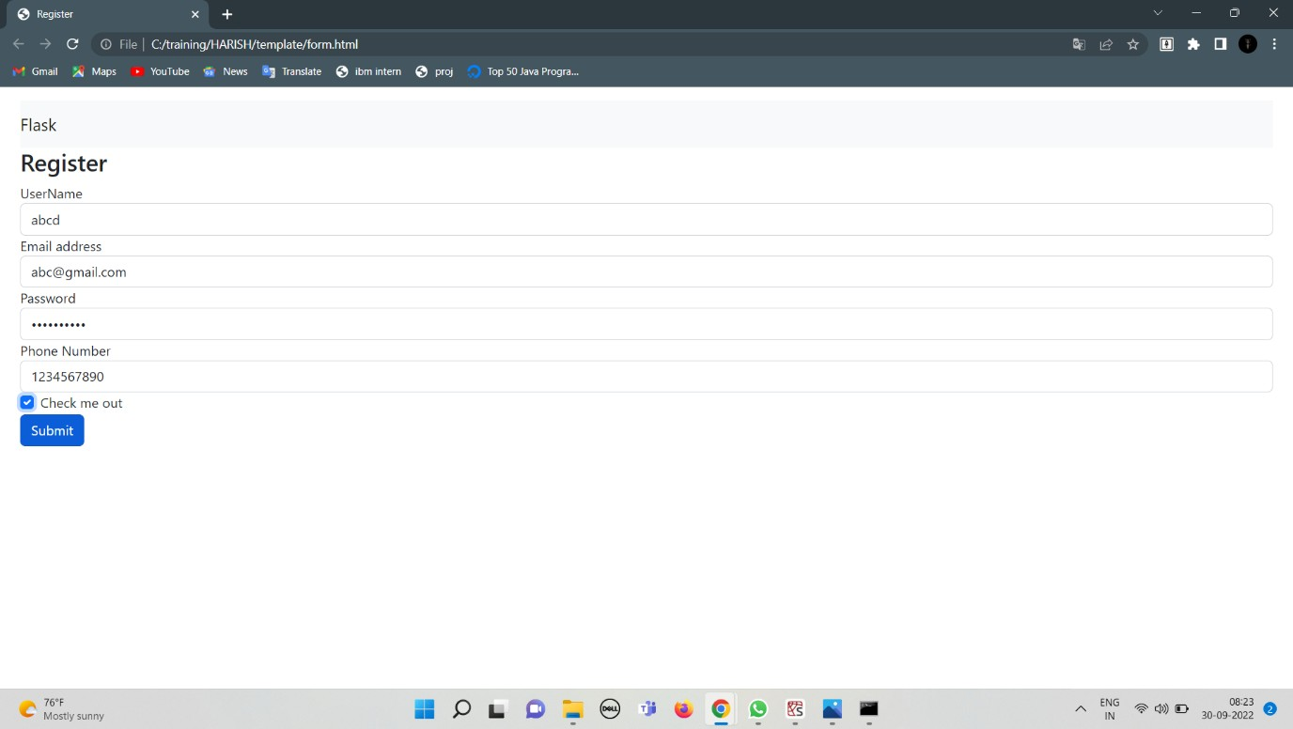

Login successful page

